**I. FA => RE**

1. Find the RE for the FA:

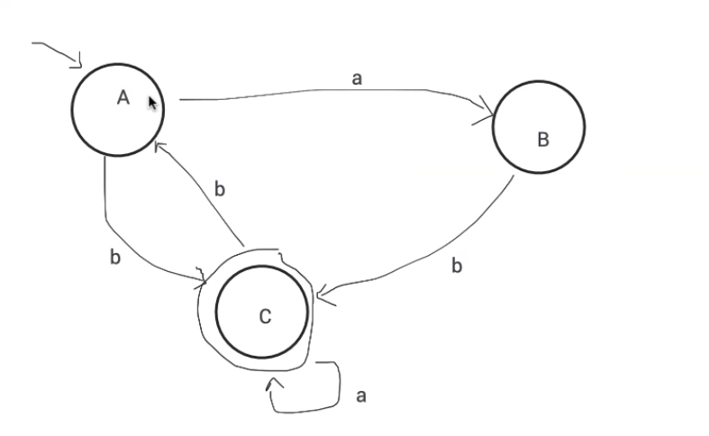

$$\left\{\begin{aligned}A= ɛ+Cb(1) \\ B=Aa (2) \\ c=Bb+Ab+Ca (\#3)\end{aligned}\right.$$

We replace (2) in (3): C = Aab + Ab + Ca ⬄C = A(ab + b) + Ca

We replace (1) in (c): C = (

⬄C = ab + b + Cbab + Cbb + Ca

⬄C = C(bab + bb + a) + ab + b**; *X = Xa + b => X = ba* (NF****)*

⬄C = (ab + b)(bab + bb + a)*

2. Find the RE for the FA:

X – regular expression that puts the FA in q1

Y – regular expression that puts the FA in q2

Z – regular expression that puts the FA in q3

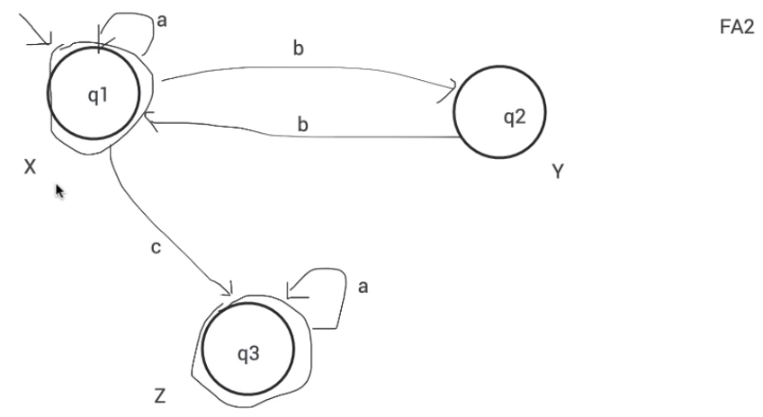

$$\left\{\begin{aligned}X= ɛ+Yb+Xa (1) \\ Y=Xb (2) \\ Z=Xc+Za (3)\end{aligned}\right.$$

We replace (2) in (1): X = $ɛ$ + Xbb + Xa ⬄ X = $ɛ$ + X(bb + a) => X = (bb + a) $ɛ$*= (bb + a)*

We replace X in (3): Z = (bb + a)*c + Za => Z = (bb + a)*ca*

We don’t need cu compute Y, it is not final state (circled)

RE = X + Z = (bb + a)* + (bb + a)*ca* = (bb+a)*(ɛ+ca*)

3. Individual:

X – regular expression that puts the FA in q1

Y – regular expression that puts the FA in q2

Z – regular expression that puts the FA in q3

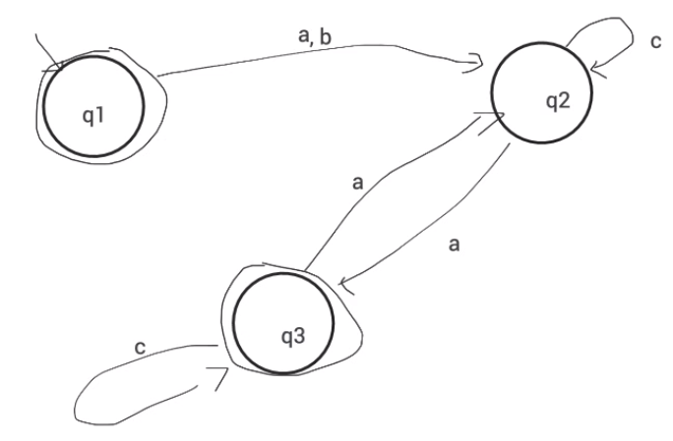

$$\left\{\begin{aligned}X= ɛ (1) \\ Y=X(a+b)+Za+Yc \\ Z=Ya+Zc (3)\end{aligned}\right. (2)$$

(1): X = ɛ

We replace X in (2)

(2): Y = ɛ(a + b) + Za + Yc => Y = Zac*

⬄Y = Yc + Za + a + b = (a + b + Za)c*

We replace Y in (3)

(3): Z = (a + b + Za)c*a + Zc

⬄ Z = ac*a + bc*a + Zac*a + Zc

⬄ Z = Z(ac*a + c) + (a + b) => Z = (a + b)c*a(ac*a + c)*

RE = X + Z = ɛ (a + b)c*a(ac*a + c)*

**II. RE => FA, RE => RG**

|  |  |
| --- | --- |
| RE | RG |
| a | S -> a |
| a + b | S -> a | b |
| ab | S -> aA, A -> b |
| a* | S -> aS | ɛ |
| $${a+ b}^{+}$$ | S -> aS | a |
| (a+b)* | S -> aS | bS | ɛ |

a) 0*1*

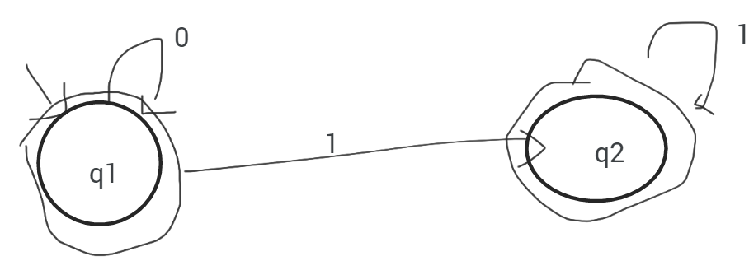

G1: 0*: S1 -> 0S1 | ɛ

G2: 1*: S2 -> 1S2 | ɛ

(S3 -> S1S2 non terminal => not regular/linear)

G3: S3 -> 0S1 | 1S2 | ɛ

S1 -> 0S1

S2 -> 1S2 | ɛ

b) 0*(1 (0 + 1))*

(0+1): S1 -> 0 | 1

(1(0 + 1))*: S2 -> 1S1 | ɛ

0*(1 (0 + 1))*:

S3 -> 0S2 | 0S3 | ɛ

S2 -> 1S1

S1 -> 0 | 1